James Dumitru

IIT PSYC 203

Project 2

1&2.) Movie Trivia Stats Efficacy

Mean: 7.9152542 Mean: 2.09126467

Median: 8 Median: 2

Mode: 10 Mode: 1.923077

Range: 11 Range:1.692

Standard Deviation: 2.51 Standard Deviation: .35495

Variance: 6.32 Variance: 1.2598951

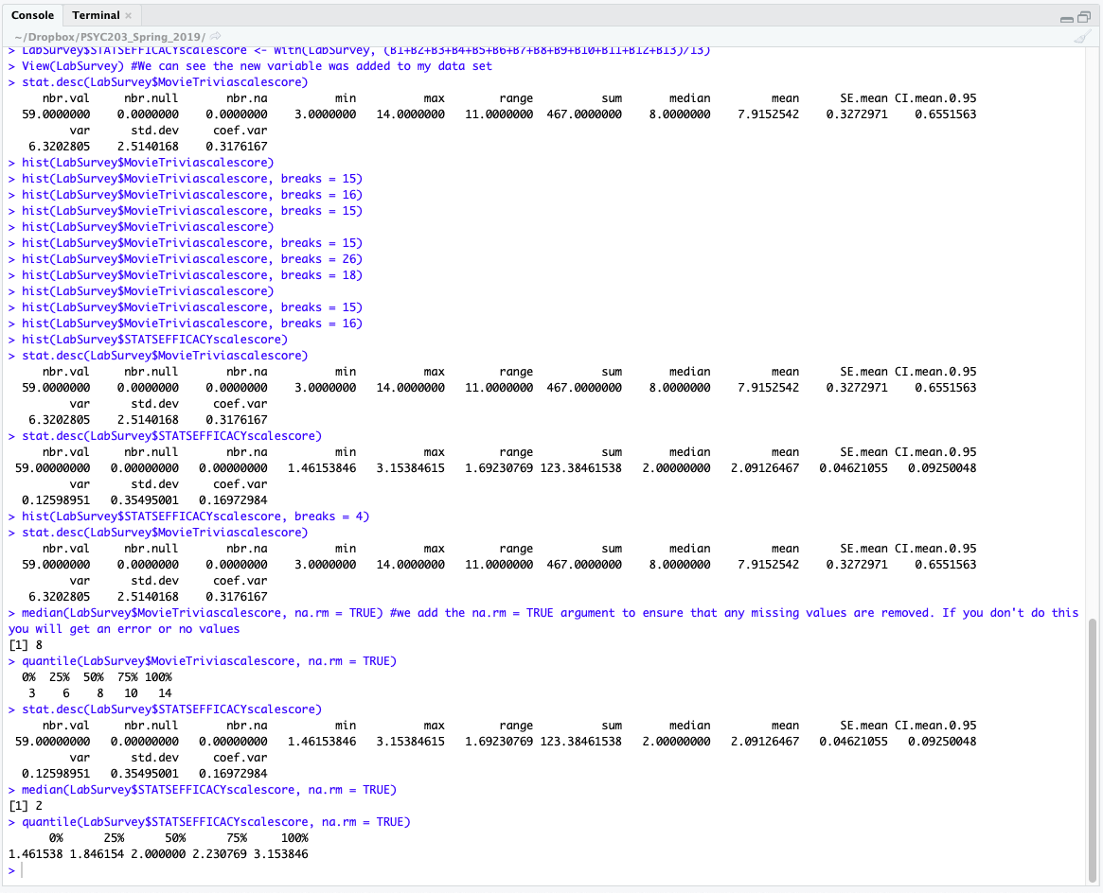

3.) Going back to the meaning of the two, Central Tendency refers to the middle of the distribution, while Variability is about the spread. If I were to report 1 of each, I would use the mean because it's generally preferred unless there is a "bad egg" In the distribution for which I'll use the Median. As for the one measure of variability, I would use the Variance because it's the most likely to be unbiased to the information.

4.) I believe the skew would go away, depending if the "bad" bar went away, if it was close to the tail and but not the end, it would enlarge the skew.

5.)

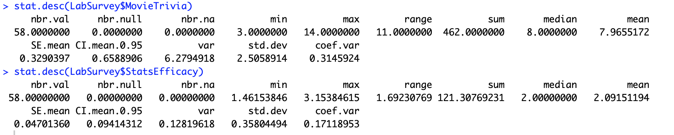

Movie Trivia Stats Efficacy

Mean: 7.9655172 Mean: 2.09151194

Median: 8 Median: 2

Mode: 10 Mode: 1.923077

Range: 11 Range:1.692

Standard Deviation: 2.51 Standard Deviation: .35495

Variance: 6.2794918 Variance: .12819618

Yes, my prediction came true, the proof is in the increase from the mean and variance. Meaning that the random case created a sort of "hole" that skewed the data even further even if it was slightly.